erretr



PLA Monitoring System

Software Requirement Specification

Version No: 1.0
Date: July 25th, 2011

Contents
1. Introduction 4
1.1 Purpose 4
2. Scope 4
2.1 In Scope 4
2.2 Out of Scope 4
3. Audience 4
4. Roles and Responsibilities 5
5. PLA (Personal Lab Automation) Overview 6
6. Functional Requirements 7
6.1 Web Application Functional Requirements 7
6.2 Web Services Functional Requirements 9
6.2.1 Tracking Tool Web Service 9
6.2.2 Statistics Web Service 10
7. Application Structure Overview 11
8. PLA Monitoring System Database Architecture 12
9. Tracking Tool Web Service 13
10. Web service for Reporting 14
10.1 Assumptions 14
11. Web Application Process Flow 15
11.1 Process Flow to Add a New Program 15
11.2 Process Flow for Adding New Person 16
12. User Interfaces 17
12.1 Program Page 17
12.1.1 Add New Program Page 18
12.2 Person Page 19
12.2.1 Add New Person Page 20
12.3 DA Page 21
12.3.1 ADD DA Page 22
12.4 Development Type page 23
12.4.1 Add Development Type Page 24
12.5 Dependency page 25
12.5.1 Add Dependency Page 26
12.6 External Company 27
12.6.1 Add External Company Page 28
Annexure 29
Index 30

User Interface 1 17
User Interface 2 18
User Interface 3 19
User Interface 4 20
User Interface 5 21
User Interface 6 22
User Interface 7 23
User Interface 8 24
User Interface 9 25
User Interface 10 26
User Interface 11 27
User Interface 12 28

Introduction

1.1 Purpose
This Document provides the detailed System Requirement Specification for design, development of features based on the user requirements for “PLA Monitoring System” Web based Application for “Novartis Institute of Biological Research” (NIBR)

2. Scope

2.1 In Scope
This document is intended for the System requirement Specification to the “PLA Monitoring System” web-based application used at NIBR. The tool is dedicated to track the usage of all PLA solutions.

2.2 Out of Scope
This application “PLA Monitoring System” will not be validated

3. Audience
This application PLA is intended for “Novartis Institute of Biological Research”
And their internal Supervisor, PLA Developers and PLA Team

4. Roles and Responsibilities
Below listed people has specific roles and are involved to manage their responsibilities
Function Name | Responsibility
Application Owner(AO) | - Represents the users of the Application  - Responsible for the definition of the application specifications  - Reviews and approves the Application Specifications
Technical Owner /Information Technology (IT) | - Provides a secure network connection  - Reviews the application Specifications
End User | Provides the input for the Application Specifications
Developer | Identifies and Develops functional specifications according to the requirements

5. PLA (Personal Lab Automation) Overview
PLA Web Application helps PLA team to track the usage of all PLA developments and also to analyze and create reports.
PLA project is categorized into 3 major parts. One Web Application two dedicated Web Services.
PLA tool provides an interface with the existing SQL Server where in, it will be accessible from a Novartis PC running on Microsoft XP SP3 or higher Version. All the development related information will be stored on a Web Server
Web Server Configuration
- Windows 2008 R2
- .NET Frame Work 4.x
- IIS 7.0
- English Version
Hardware and Software Requirements
Hardware/Software | Name | Serial Number/ Version
Software | 1. Windows XP | SP3
 | 2. Engine | Application Portfolio  WU_NIBR – TS – GLOBAL _ 003
WorkStation PC | All PCs (Engine and LEAD)

6. Functional Requirements
PLA Monitoring System has confined Functional Requirements. This section provides the complete information about the PLA monitoring System functionality in Novartis Environment under their specified concrete operating conditions of regular work.
PLA monitoring System consists of One Web Application and two dedicated Web Services

6.1 Web Application Functional Requirements
- Web Application will be accessible from a Novartis Computer Engine PC or lead workstation (Windows XP SP3 or higher, .NET Framework 3.5 SP1 or higher, English version) by any user with in the Novartis network.
Note: No Authorization is required
- This Application should be compatible atleast with IE8 , Firefox and Safari
- This Application should be capable of managing the information in the tracking SQL database
- To insert a new program user should be able to enter the listed parameters
  - Master name(Mandatory)
  - Version (Mandatory)
- Frequency
- Delivery Date
- Development Type
- PLA Owner
- Requestor
- Deputy
- Time Saved
- External Company
- Dependency
5. User should be able to enter a new person record as Requestor or Developer with the below parameter
- Name
- Site
- DA
6. The user should be able to select/enter information coming from SQL table to a program
- DA (mandatory field)
- Development Type
- Developer name (PLA_OWNER_ID)
- Requestor Name
- Deputy Name
- Site
7. The user must be able to Insert, Delete and update the below fields
- DA
- Externals
- Development Type
- Dependency
8. The User must be able to update the History table. No manual inserts allowed
9. User must be able to delete entries in PROGRAM and HISTORY tables

6.2 Web Services Functional Requirements

6.2.1 Tracking Tool Web Service
These Web Services receives the input from User with four mandatory parameters. These values are inserted into the PROGRAM and HISTORY database tables. Validation for duplicate entry is required. In PROGRAM table MASTERNAME and VERSION should be unique.
- Web Service will be accessible from a Novartis Computer Engine PC or lead workstation (Windows XP SP3 or higher, .NET Framework 3.5 SP1 or higher, English version) by any user with in the Novartis network.
Note: No Authorization is required
- Establishment of Encrypted connection to the SQL Server is required for standard security in config file
- All PLA tools like VB Script , C#, VB.NET, ASP.NET or pipeline pilot should be able to access the web services with below mandatory parameters
  - Master name
  - Version
  - User name
  - Date
4. Automatic SQL database update for new records should be established
5. Application has to check the availability of the Database connection
6. Application should check for the duplicate entry in the PROGRAM table based on the MASTER NAME and VERISON
7. If there are no entries in the PROGRAM table for the specified MASTER NAME and VERSION the application should be able to insert a new record into the PROGRAM TABLE
8. And also that new record has to be inserted into the HISTORY table with PROGRAM ID generated from PROGRAM table along with the User_ID and Date
9. While updating the records if the SQL server is not available the information should be stocked by the application and should empty the buffer whenever the SQL Server is available.

10. If an error occurs during this process a log file should be created and it has to be sent to the user right after the error occurrence from NIBR.PersonalLabAutomation@novartis.com through mail
Note
Log File must contain the information of MASTERNAME, VERSION, USERID, DATE and Error Message

6.2.2 Statistics Web Service
- Web Service will be accessible from a Novartis Computer Engine PC or lead workstation (Windows XP SP3 or higher, .NET Framework 3.5 SP1 or higher, English version) by any user with in the Novartis network.
- The application should retrieve information from a SQL Server and create predefined graphs
- Establishment of Encrypted connection to the SQL Server is required for standard security in config file
Note
Output format Specifications has to be confirmed from Novartis

7. Application Structure Overview

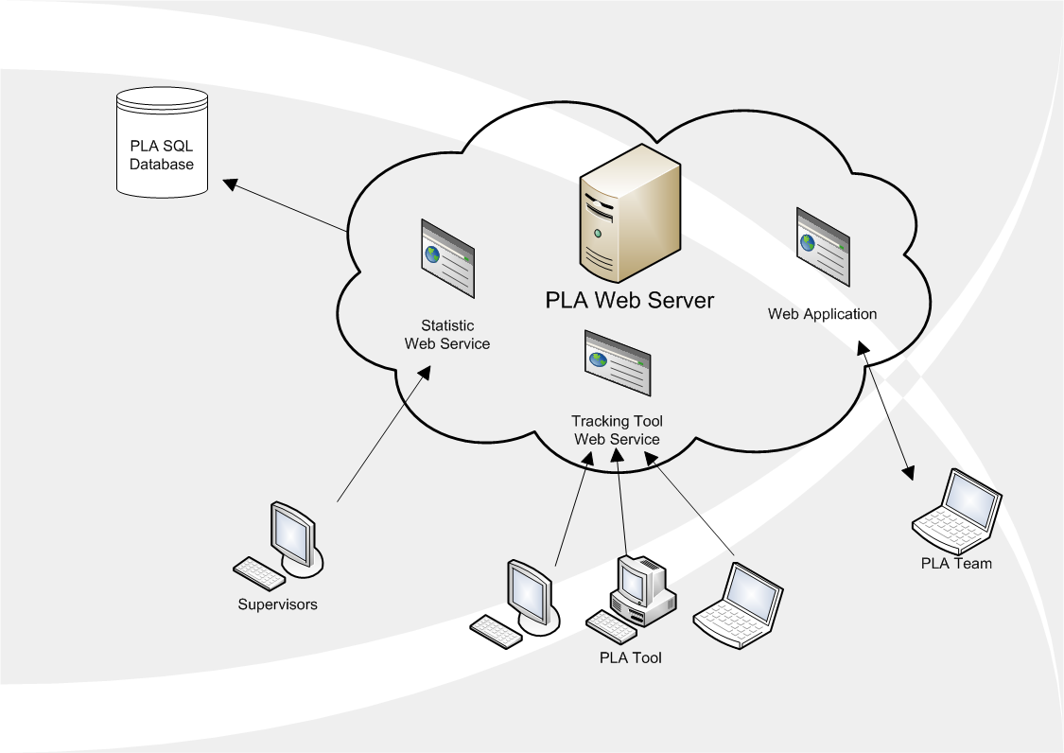
Supervisors can be able to view the data only
PLA team works on the Web Application
PLA Tool uses the Tracking Tool Web Service

8. PLA Monitoring System Database Architecture
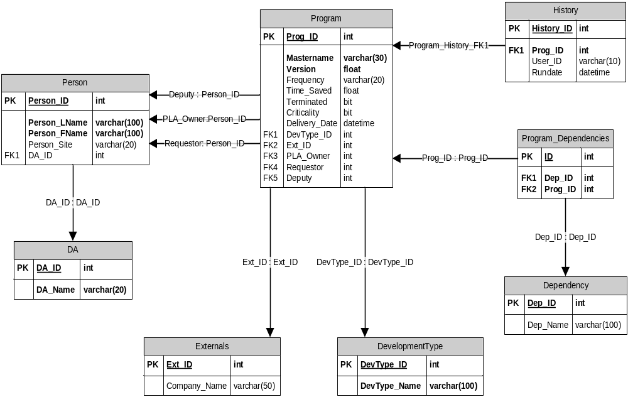

9. Tracking Tool Web Service

Tracking tool Web service is a normal web service without any UI where in user can call it by merging it in the required script.
PLA tools use this Web Service with 4 mandatory parameters
  - Master name
  - Version
  - User name
  - Date
This Web Service helps to receive input data and inserts it into the data base.
- If an error occurs during this process a log file should be created and it has to be sent as mail attachment to NIBR.PersonalLabAutomation@novartis.com right after the error occurred.
- While updating the records if the SQL server is not available the information should be stocked by the application and should empty the buffer whenever the SQL Server is available
Note
Log File must contain the information of MASTERNAME, VERSION, USERID, DATE and Error Message

10. Web service for Reporting
- Novartis will provide report formats

10.1 Assumptions

- DA, Externals, Development Type and Dependency are all predefined tables, where in the data cannot be Inserted or Deleted by user but can only be modify/Update using Edit.
- Web services are called in main application/internal application.

11. Web Application Process Flow

11.1 Process Flow to Add a New Program
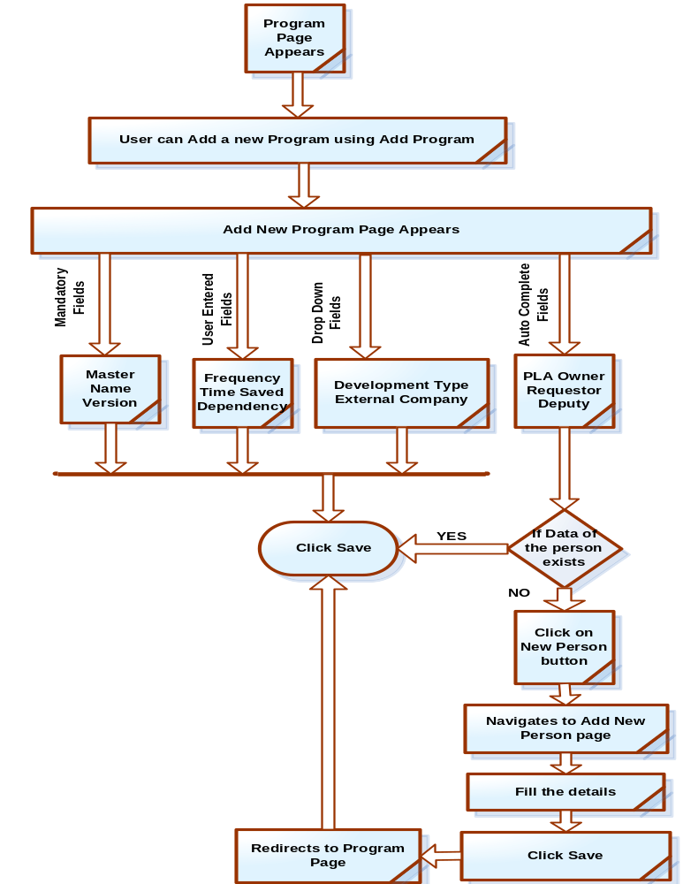

11.2 Process Flow for Adding New Person
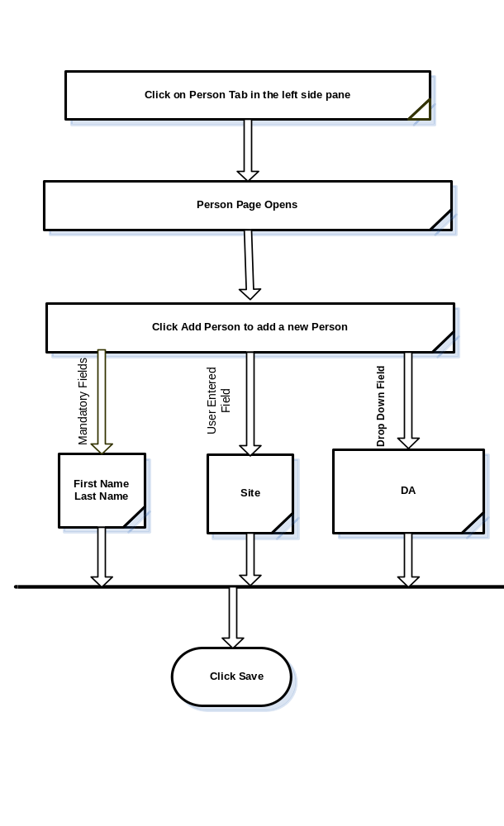

12. User Interfaces

12.1 Program Page
User Interface 1
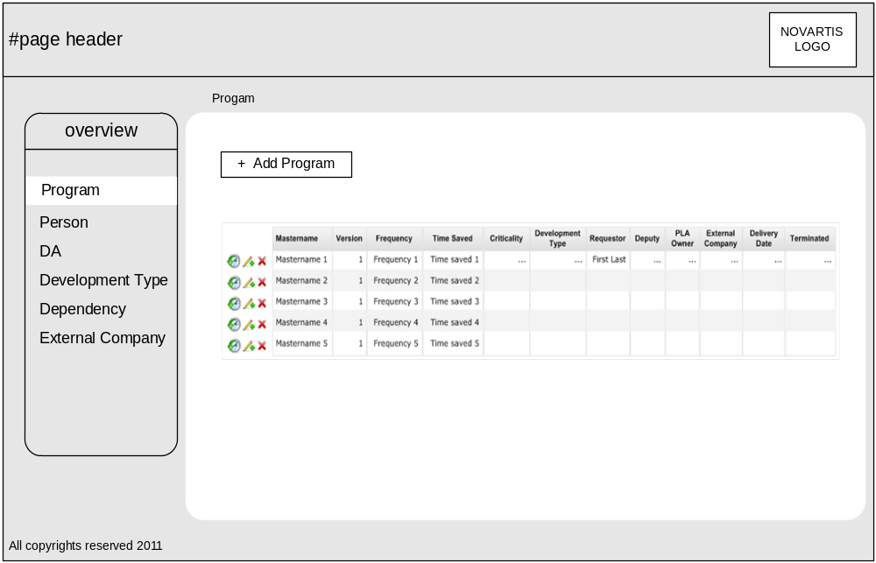
- When User access PLA application, Program Page will be landing page.
- In this page user can Edit and Delete the program information using the Edit and Delete options shown as
- Program History can be viewed using History option
- User can add a new Program using “Add Program” button.
- It navigates to the “Add New Program” page
- In the “Add New Program” page user can enter the required information and Click “Save” then the details will be saved and stored in the database in Program table

12.1.1 Add New Program Page
User Interface 2
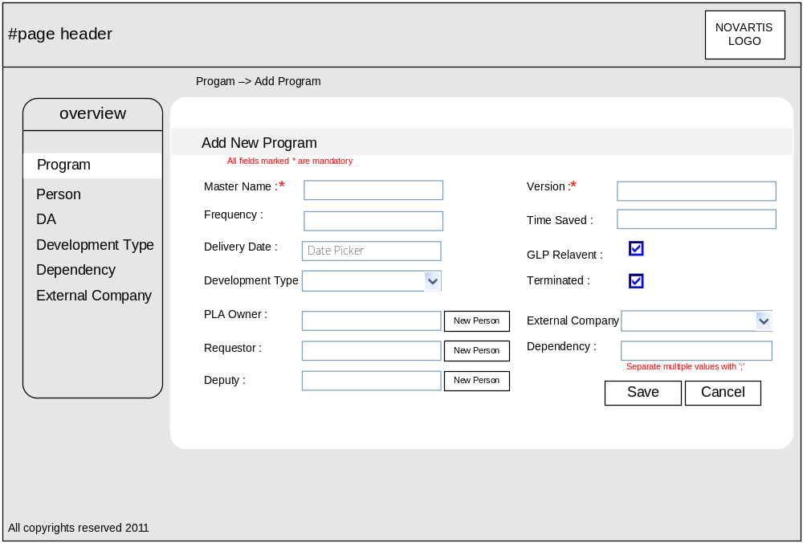
Mandatory Fields
Master Name and Version. User must enter information in Master Name and Version fields
AutoComplete Fields:
PLA Owner, Requestor, Deputy are all auto complete fields, when user enters initial three characters then remaining name will appears in that field. Information from the PERSON table will be considered here to auto complete the information in PLA Owner, Requestor and Deputy fields.
Drop Down Fields:
Development Type and External Company both these fields are Drop Down fields where in user can select the data from the Drop down
After entering all the information user can save this information into the database using “Save” button.
User can add new person by clicking on “New Person” and Add Person page will appear. Rest of the functionality is same.

12.2 Person Page
User Interface 3
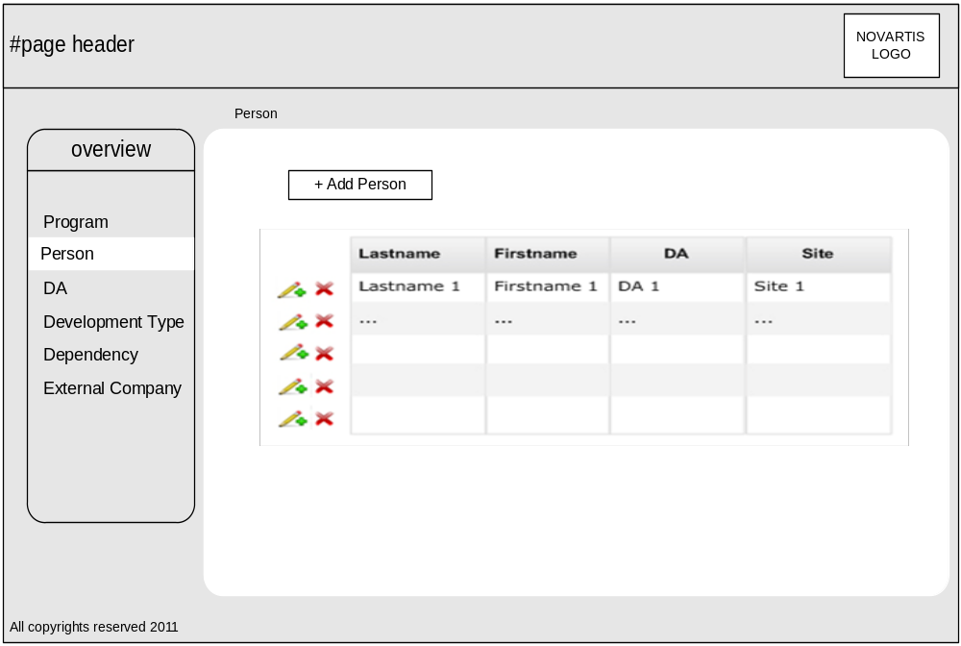

In Person Page all the information from the relevant Database tables will be displayed in a tabular format.
- In the Person Page user can Edit data using option and can Delete data using option
- The data for the Lastname, Firstname, DA and Site can be retrieved and displayed for the existing data from Person table in the database
- DA information from DA table
- User can add a new person using Add Person option
- If User clicks Add Person the below page appears

12.2.1 Add New Person Page
User Interface 4
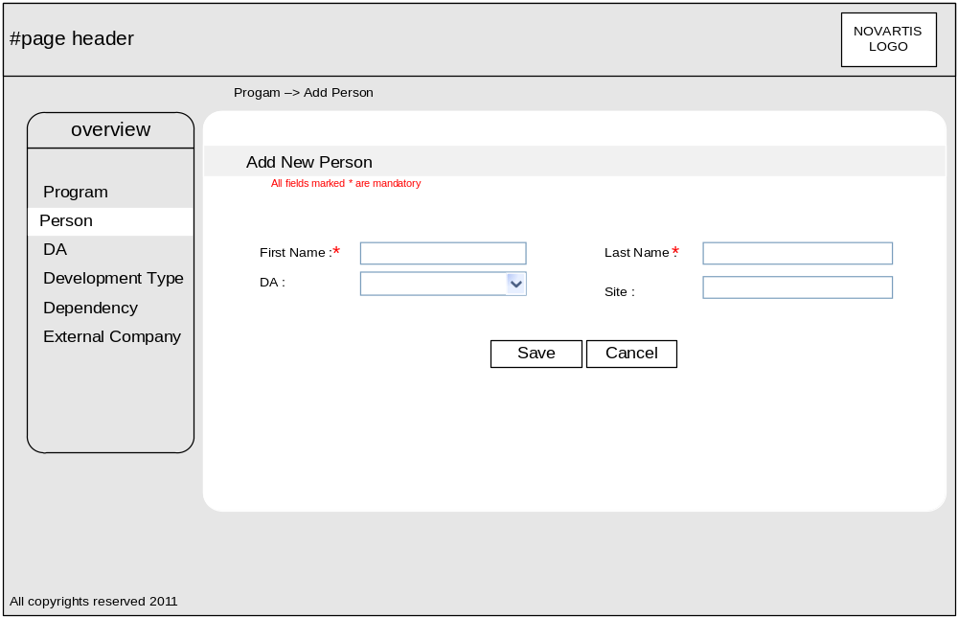

- In this page user can add a new person. First Name and Last Name fields are mandatory fields
- DA field will have data from predefined DA table
- User has to enter the Site information
- Click Save to save the person information and it automatically gets updated in the Person Table

12.3 DA Page
User Interface 5
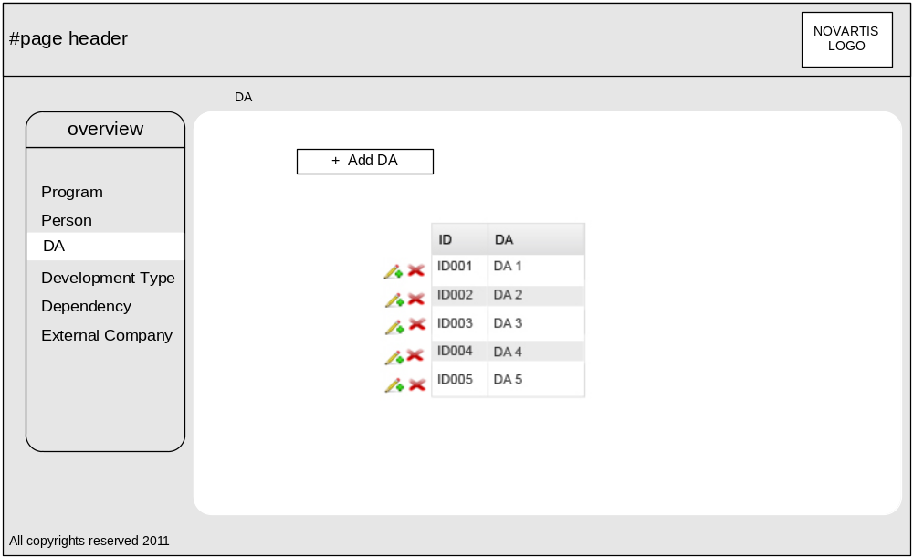
- In DA Page user can delete data using Delete option Update the existing data using Edit option
- User can add a new record using Add DA button in the above page then below page has to appear

12.3.1 ADD DA Page
User Interface 6
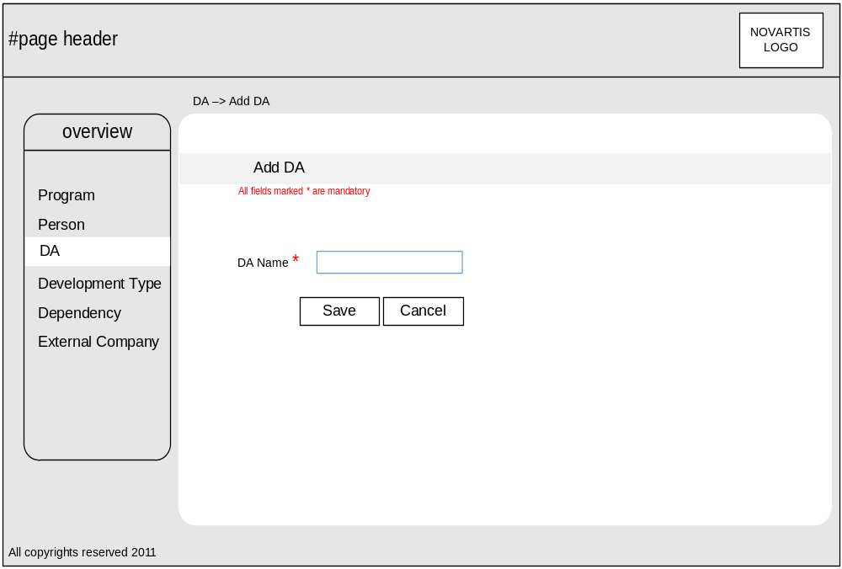

- Click on Add DA button and enter the DA Name in the DA Name text field
- Click Save button
- New record has to be inserted into the DA table under DA_NAME field

12.4 Development Type page
User Interface 7
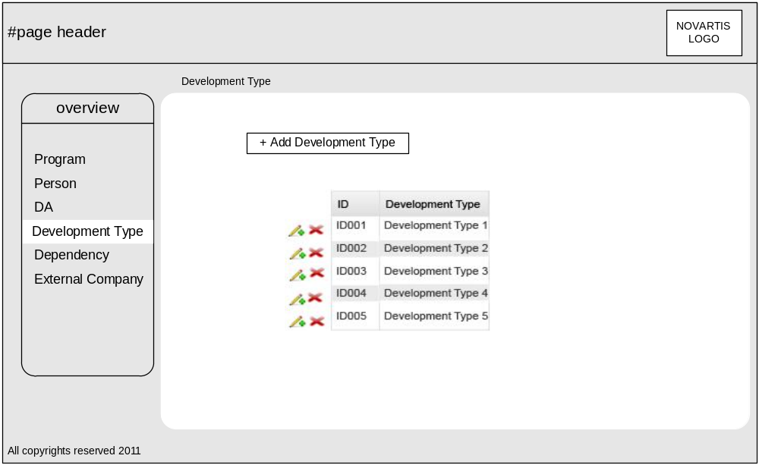

- In Development Type Page using Edit and Delete option user can Update and Delete the data
- User can also insert a new record using Add Development Type button in the above page

12.4.1 Add Development Type Page
User Interface 8
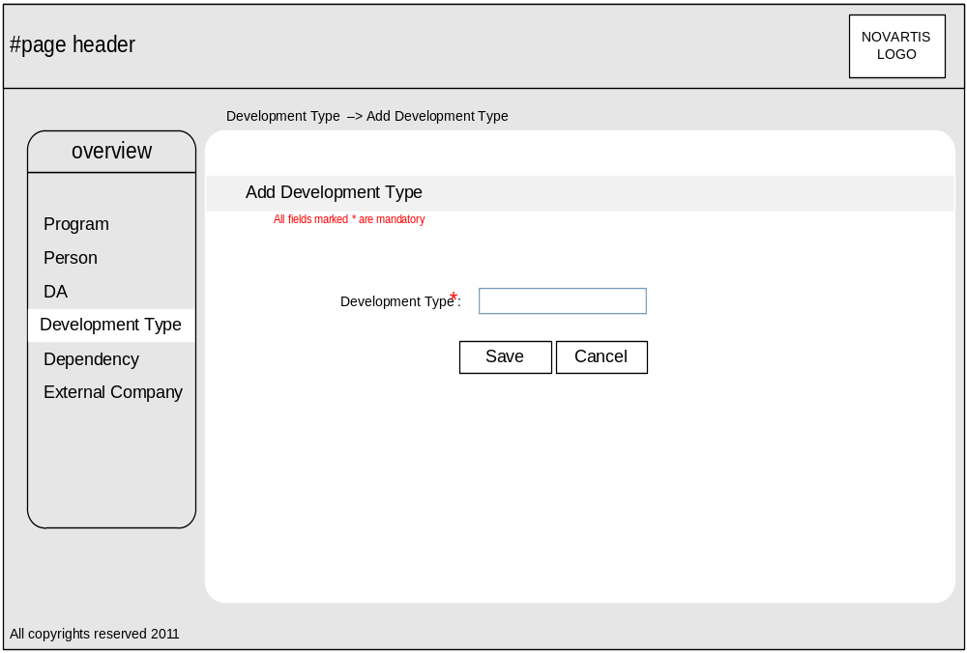
- Click Add Development Type enter the information regarding Development Type in the Development Text field and click Save button
- Then the new record of the Development type automatically has to be inserted into the Development Table under the field DevType_NAME

12.5 Dependency page
User Interface 9
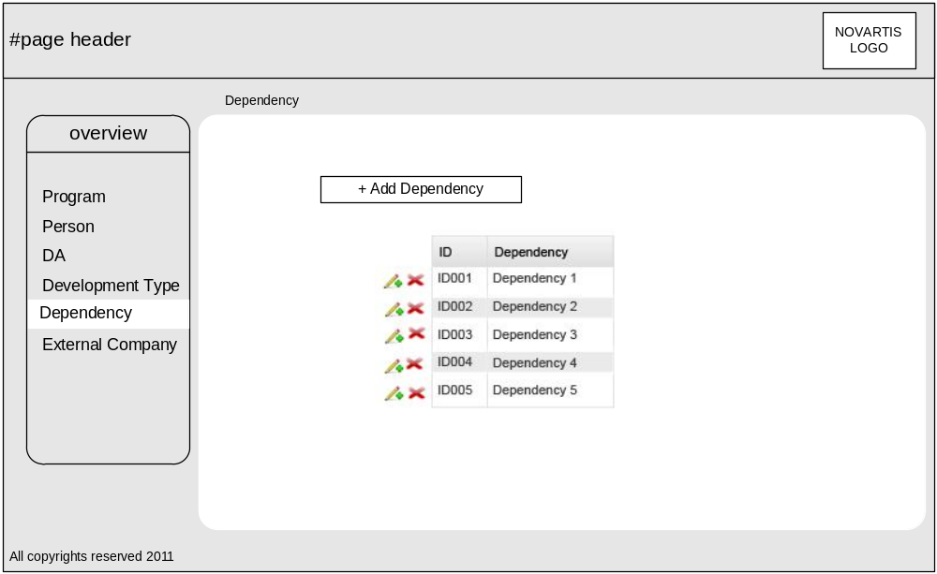
- In Development Page using Edit and Delete option user can Update and Delete the data
- User can also insert a new record using Add Dependency button in the above page

12.5.1 Add Dependency Page
User Interface 10
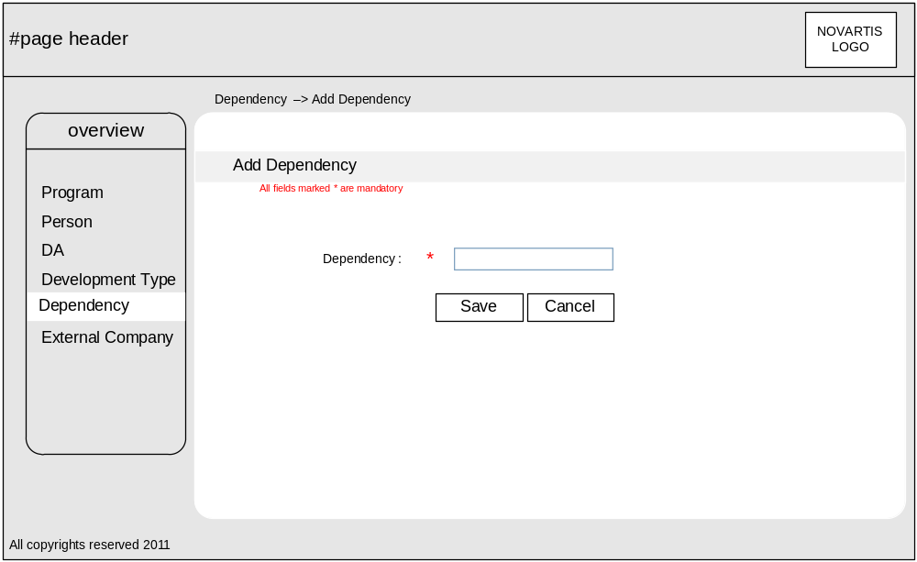
- Click Add Dependency enter the information regarding Dependency in the Dependency Text field and click Save button
- Then the new record of the Development type automatically has to be inserted into the Development Table under the field DevType_NAME

12.6 External Company
User Interface 11
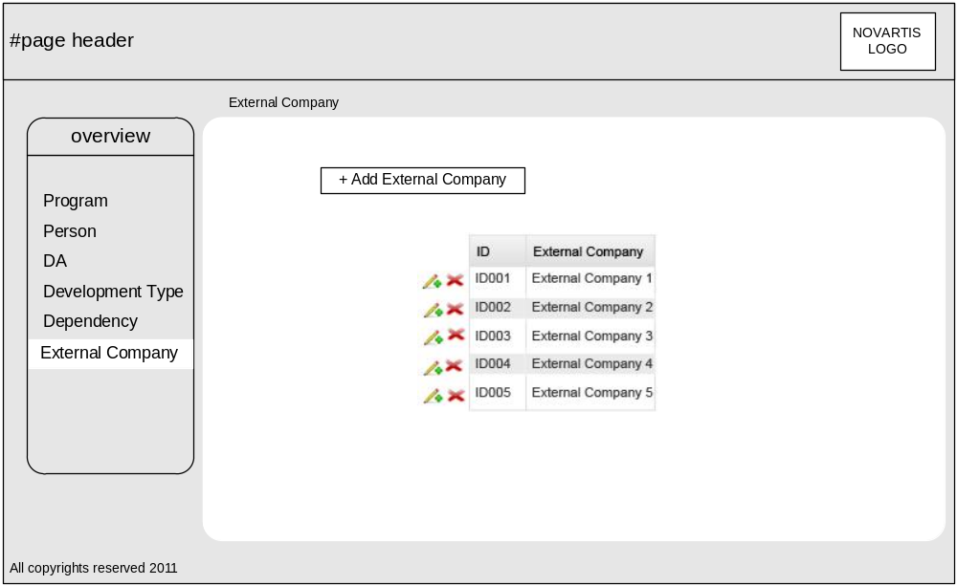

- In External Company page using Edit and Delete option user can Update and Delete the data
- User can also insert a new record using Add External Company button in the above page

12.6.1 Add External Company Page
User Interface 12
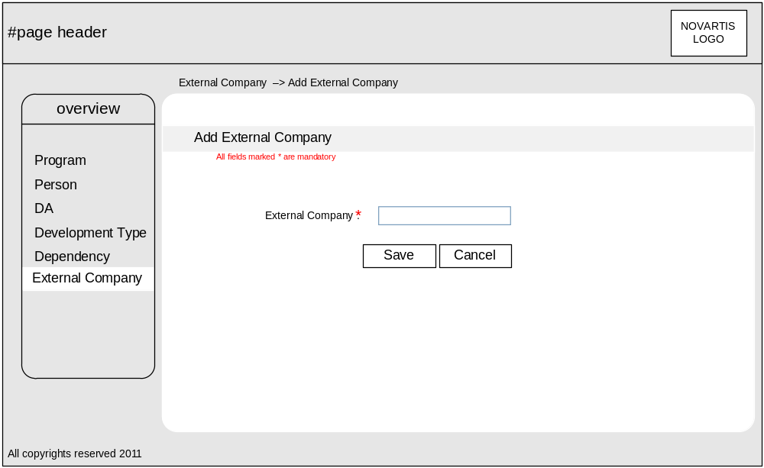
- Click Add External Company
- Enter the information regarding External Company in the External Company text field and click Save button
- Then the new record of the External Company automatically has to be inserted into the External Company Table under the field Company _Name

Annexure

Term | Abbreviation | Description
PLA | Personal Lab Automation | Used for the internal purpose of Automation at Novartis
NIBR | Novartis Institute of Biological Research | Biological Research Institute
DA | Disease Area | Represents a specific disease name

Index

”
” (NIBR) · 4
A

Application Owner · 5
Application Owner(AO) · 5
D
DA · 8
Delivery Date · 8
Dependency · 8, 9
Deputy · 8
Deputy Name · 8
Developer · 6
Developer name · 8
Development Type · 8
E
End User · 6
External Company · 8
Externals · 8
F
Frequency · 8
M
Master name · 7
N
Name · 8
NIBR · 4
P
Personal Lab Automation · 6
PLA · 6
PLA Developers · 5
PLA Monitoring System · 4, 5
PLA Owner · 8
PLA Team · 5
R
Requestor · 8
Requestor Name · 8
S
Site · 8
Statistics Web Service · 10
Supervisor, · 5
T
Technical Owner · 6
Technical Owner /Information Technology (IT · 6
Time Saved · 8
Tracking Tool Web Service · 9
U
User Interfaces · 16
V
Version · 8
W
Web Application · 7, 14
Web service for Reporting · 13

